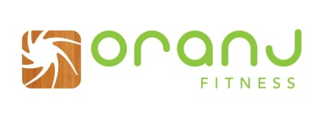
You have a corporate rate already!!
Fitness Passes | Regular Price |  | Your Price | Cost Per Class | Cost Per Month
Drop-in |  | $22 | $16 | N/A | N/A
5 punch pass |  | $90 | $67 | $12.80 | N/A
10 punch pass |  | $170 | $127 | $11.20 | N/A
20 punch pass |  | $320 | $242 | $9.75 | N/A
1 month unlimited |  | $195 | $146 | N/A | $146
3 month unlimited |  | $525 | $394 | N/A | $131
6 month unlimited |  | $960 | $720 | N/A | $120
1 year unlimited |  | $1620 | $1215 | N/A | $101
This means that you will receive a 25% discount at oranj Fitness on drop-ins, punch passes, and membership rates. See below the price list that are offered to your employees. Just come in and get boogying!
What Does Oranj Fitness Offer?
In our 6000sq.ft. studio, you can attend more than 110 classes per week, ranging from yoga, barre, boot camp, spin, and dance. We open as early as 6am and close as late as 9pm on some days. Feel free to get a vegan, superfood smoothie after class or a private/group personal training session. We also offer childcare and we have just expanded our retail section.
Keep us in mind for corporate events! We even do lunch time yoga/fitness classes at your place of business.
All you need to bring is yourself!
All of our yoga mats, sweat and shower towels are complimentary. We even have spare shoes and gym gear should you have a forgetful day. In our fully equipped facilities, you can wash and style your hair with Kevin Murphy hair products provided by Burke Hair Lounge. We are really the one stop shop for all your fitness and maintenance needs.
If you have any further questions about your existing corporate rate, please feel free to contact us directly under 250.448.5759 or Tina Mandl (owner oranj Fitness Kelowna) at tmandl@oranjfitness.com.

